# Lesson 4 Designing an Experiment

## Choose “subject” – unit of diversion

We can use event-based assignment for choosing either the control or experiment group for each pageview. But for a user visible change, we want to basically assign people as opposed to events. But how to determine who a person is?

* Each id? But each person could have multiple logins, such as both consumer and corporate accounts.
* Anonymous identifier like cookie, which is tied to a single browser or a single device? But users can use different devices or browsers.

So, in any case, if we’re trying to assign a person, we will use some imperfect proxy.

**Pros and cons for each unit of diversion**

Commonly used:

* User id, such as login email address
  + Stable, unchanging
  + Personally identifiable
* Anonymous id, such as cookie
  + Changes when we switch browser or device
  + Users can clear cookies
* Event
  + No consistent experience
  + Use only for non-user-visible changes

Less common:

* Device id
  + Only available for mobile
  + Tied to specific device
  + Unchangeable by user
* IP address
  + Changes when location changes

Check if subject can be switched between control and experiment groups.

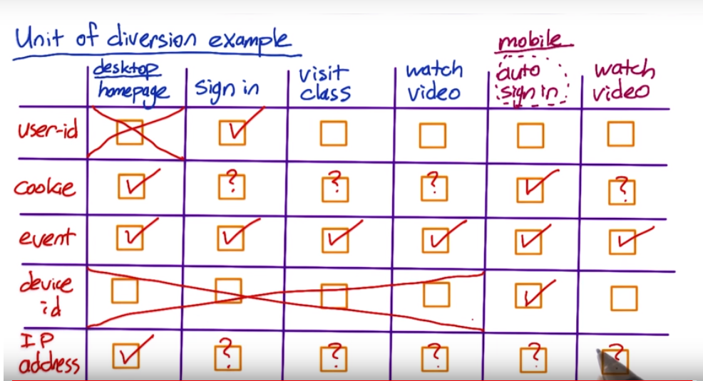

? means maybe